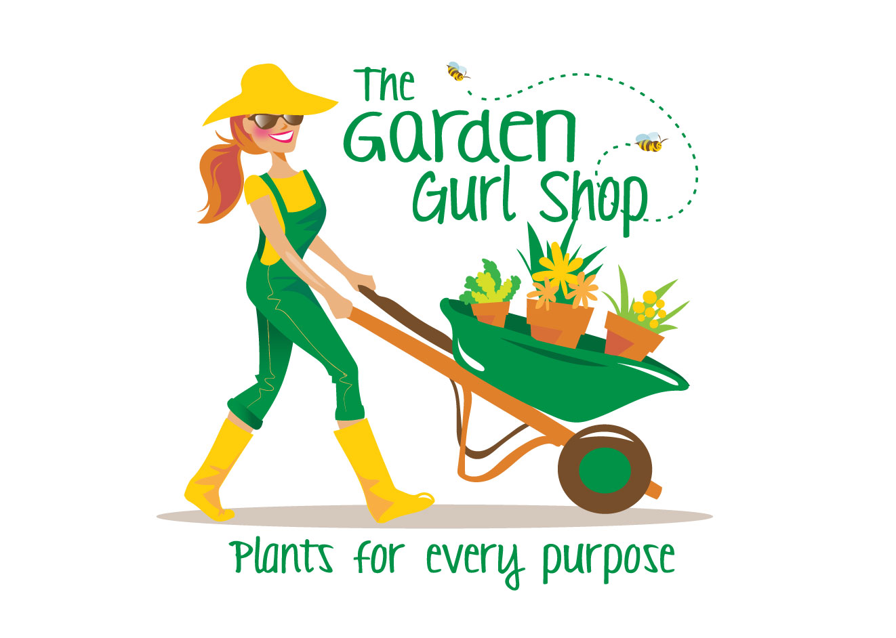  330-447-1844  Call / Text anytime with questions  www.facebook.com/thegardengurlshop | Plants 101  What you need to know (and nothing you don’t)  Annuals  They last until frost, they won’t come back next year, but they bloom from May until Oct so you get your money’s worth and sometimes if you’re lucky they self seed
Watering:  Most annual hate sitting in water, they drown so you are better off adding water. I use a couple methods  The finger method. If its dry to my nuckle I water or if I know it’s going to 85 + outside and sunny, I soak them in the morning to ensure I don’t stress them. (I’ve come home to wilty plants) I always try and water in the A.M. to let the leaves dry thoughout the day. | Fertilizing:  All of my flowers get fertilizer once a week, period! (sometimes more) I use higher phosphorus as in 2-5-0. Anything with a higher middle number that promotes blooming and root growth. Also compost and compost tea is key because of the microbes, it helps improve your soil and your plants soak up the fertilizer more readily.
Container or Ground?  You can do either however I suggest always using either Pro Mix or Better Gro potting mix to plant them in no matter what. It helps them absorb fertilizer better. It’s your best insurance policy for survival of any plant period. Worm castings, Compost Tea, and Organic Fertilizers are by far my favorite. There is a lot of good products out there, trust me. | Care:  (the fun stuff)  Whenever you see a bloom that’s died, cut it off to where the stem is sending out another flower. If they get straggly cut them back ½ way. Really! 6 inches is okay if you need too. They will come back fuller; just fertilize them next time you water.

